CONGRESS REGISTRATION FORM |  |  | 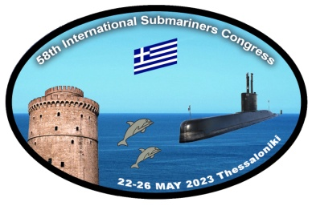  Hellenic  Submariners Association  CAPSIS  HOTEL THESSALONIKI  Thessaloniki, Greece  Monastiriou Str.546 29  ZORPIDIS TRAVEL  SERVICES ATHENS  CANCELLATION POLICY  Free release  until the 25/01/2023  .  50% cancellation fee  until the 05/04/23  100% cancellation fee 06/04/23-22/05/23  There is significant demand for these dates, hence we cannot be flexible
PERSONAL DETAILS
Last Name | First Name | Middle
Rank | Position | Association
Passport No | Expiration Date State Issued | Date of Birth
Telephone / Mobile | Email  S M L XL XXL | Home Phone  XXXL
Sex | T-Shirt Size
ADDRESS DETAILS
Street Address

City | Country State/Province | Zip/Postal Code
HOTEL ROOM
Single room no. | Double room no. | Triple room no.
ACCOMPANYING GUEST
Last Name | First Name | Middle
Passport No | Expiration Date State Issued | Date of Birth
 | S M L XL XXL | XXXL
Sex | T-Shirt Size
SECONTARY ACCOMPANYING GUEST
Last Name | First Name | Middle
Passport No | Expiration Date State Issued | Date of Birth
 | S M L XL XXL | XXXL
Sex | T-Shirt Size
Arrival & departure information
*In case you do not know yet your flight number for the arrival / departure, you can send it by email later. You have to know that transfer from and to the airport will be available only on May 22nd and May 26th .
Arrival Flight number | Date and Time
Departure Flight number | Date and Time
Special requirements (e.g. dietary, meals, disabilities, etc.) :
PAYMENT METHODS

by Credit Card
VISA / MasterCard / Dinners

By Bank Transfer
BANK ACCOUNT INFORMATION:
Bank: EUROBANK
Swift Code: ΕRBKGRAAXXX
Account Number: 00 26 00 25 41 02 01 71 38 23
IBAN GR1202600250000410201713823
Beneficiary account name: KONSTANTINOS MITSOPOULOS MONOPROSSOPI SA
Address of the Beneficiary Account Name: MITROPOLEOS 5, 10557 ATHENS

Please charge the amount for your registration fee & hotel reservation until 06th April 2023. There is guarantee for the return of the deposit (or the amount you have payed) if there will be no at least 135 participants for the congress until 24th January.

Date / / Signature .

